Lab 9 manual: Momentum and Impulse
Dr. D. Beznosko
10/31/2022
For PHYS 1111L and PHYS 2212L
(Lab outcomes: Use wireless sensors, data analysis using Pasco Capstone software [1], drawing conclusion from line fit model, area under the curve, $χ^{2}$ test application.)

Abstract
This experiment allows to compare the two quantities that are supposed to be equal using a linear fit. The $χ^{2}$ method are used to obtain the fit quality, the error on the slope is obtained from the linear regression. Other software fitter use is allowed. The conclusions of the momentum and impulse equality are drawn from the slope and error.

Introduction
The Newton’s second law was initially formulated as the impulse and momentum form, not as the most known $F=ma$ equation. This is what we will explore in this lab and verify the equality of the momentum to the impulse. You can add some information about Newton, Newton’s laws, and similar historical facts here. How do we use Newton’s laws every day?
The new skills will include the use of the computer-based data acquisition with wireless sensors and use of the Capstone software for data analysis. DO NOT SAVE THE OPEN FILE!

Experimental Setup
An experimental setup schematic is shown in Figure 1 and includes the wireless cart that can be red or blue (Figure 1a) and the metal track (Figure 1b). The cart sensors are connected to a computer via Bluetooth for readout.

Figure 1: The experimental setup schematic. A blue or red wireless cart (a) is used to measure the force and speed while moving on the metal track (b).
a)
b)

Procedure
First, setup the cart and make sure that your computer is connected to your cart (each has a serial number displayed). Zero the force sensor (do this before each run). Invert axes as needed.
Weigh the cart. Note the error of the weighing.
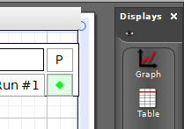
Do several tests runs until you feel confident using the system. Place the cart on the track, start the data acquisition and give it a steady yet soft push for about a second or so. The cart will continue moving after you stop pushing (note that pulling may be an option as well). The push shouldn’t be very strong so that cart doesn’t crash hard into the other side of the track!
Make sure that the data is displayed on the graphs! You want both the force vs time and the velocity vs time – so, two graphs need to be displayed side to side.
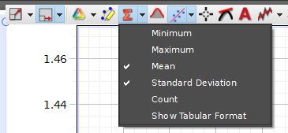
After you are confident in using the system, do the first data run. On the velocity graph, highlight the horizontal part of the data after you stop the push (at least 15-25 points or so) and write down the mean and standard deviation. This is your final velocity value and the statistical error. Now move and adjust the selection 4 more times – the stdev of the means is systematic error (because the velocity decays due to friction and we ignore it, thus friction is the source of this systematic error).
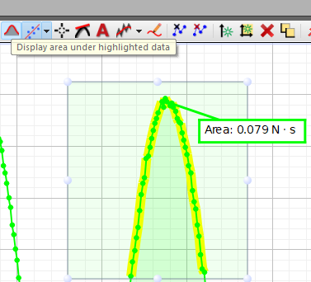
At the start of the velocity data, there is also a horizontal part of the data around 0. This is initial velocity. Since we will not use it in out calculations, find the standard deviation of this ‘0 part’ of the plot, if any, and use it as part of systematic error – this shows the cart sensor performance. Combine both errors in quadrature.

Figure 2: The highlighted part of data and the Mean and Standard deviation values.
Now for the Force vs time plot. Its 0 before and after your push. Find the standard deviation of those two parts, average the two values – this is your statistical error.
As shown in Figure 2 with a blue arrow, use this tool to display the area under the curve. Recall that area under the curve is the equivalence of the left-hand side of the equation 2. Select the data points that correspond to you pushing the cart and record the total area. Repeat the selection 4 more times, trying to select a bit more or less of the points each time. Use the average as the value for the area and the stdev as the systematic error. (Hint: sometimes you need to increase the precision to see more decimal points for the values displayed.) Combine both errors for this quantity in quadrature as usual.
Do 4 more data runs. You should end up with five final velocity values (and error) and five values for the area under the force vs time curve (also with error).

Experimental Data
Organize the results of the measurements in tables such as Table 1. The error can be listed in a different column (this is more convenient if copied from Excel), or as value ± error unit. Don’t include every single measurement here, only relevant means, stdev etc. if you measured same values few times. All data values may be included in the Appendix if desired (as screenshots for this lab?).
Table 1: Experimental data sample table.
Area under curve, N . s | Final velocity, m/s

Provide description about each entry or table as needed, don’t just leave the table without text in this section. Organize well so that data takes less space, but everything needed is included.

Theory
The impulse and momentum equation is given here in the differential form in eq. 1. PHYS2211L students should show how either eq. 1 can be derived from Newton’s 2nd law or the wise versa, show that eq. 1 becomes Newton’s second law with couple of simple steps.
$$F\left(t\right)dt=mdv\left(1\right)$$
is written using the force $F\left(t\right)$ that can vary in time, the body mass $m$ and the instantaneous velocity $dv$.
Now, if the force $F\left(t\right)$ acts on the body, we can re-write this in the integral form:
$$\int_{0}^{t}{F\left(t\right)dt}=\int_{v_{i}}^{v_{f}}{mdv}\left(2\right)$$
In the case when the mass of the object is a constant, the right-hand side of eq. 2 becomes a familiar momentum equation:
$$\int_{v_{i}}^{v_{f}}{mdv}=m\left(v_{f}−v_{i}\right)=mΔv\left(3\right)$$
The left-hand side of eq. 2 also can become just $Ft$ but only if force is constant. In our experiment, force is changing with time, thus the left-hand side of the equation 2 is replaced by the area under the curve – which is a geometric equivalent of the integral.

Analysis
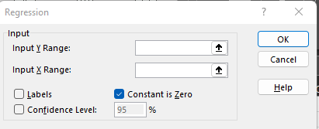
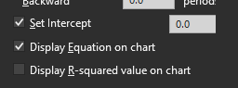
The goal of this lab is to show the equality from equation 2 to be true. For that, we will use a linear fit and linear regression to demonstrate this equality in a simple fashion. Now we need to analyze the results. From eq. 2, how do you expect the plot to look like? What would be the expected values of the slope and the intercept of the line? If right side of equation equals to 0, what should the left side equal to?
Plot the $m_{cart}v_{final}vs$area under the force vs time curve. Include all error bars. Add a linear trendline. Find the $χ^{2}$. Do the linear regression. Remember to set the constant to zero in the regression. Do the same for the trendline as well.
For PHYS2211L: calculate the $χ^{2}$ value for the line equation $y=x$ (with the slope = 1) in addition to the trendline equation that is given by excel. You can do this using the same template that was provided for another lab before by changing the parameters for the f(x) column. Details: instead of using $f\left(x_{i}\right)$ equation, just use the $x_{i}$ values directly! This will reduce the equation to:
$${χ^{2}}/{ndf}=\frac{\sum_{i=1}^{points}{\frac{{\left(y_{i}−x_{i}\right)}^{2}}{σ_{i}^{2}}}}{ndf}$$
Here, you should combine the errors for each y and x point into a single value (in quadrature as usual) and use the result for the $σ_{i}$. Note that the meaning of $χ^{2}$ is a bit different here: you are comparing the two data sets between each other and not the fitted function and data. This is called a $χ^{2}$ test.
Convert the $χ^{2}$ value to p-value probability for the given equation and for this model (that is, with forcing the fit to cross the 0,0 point and without it). For that, use some calculator that can do this function. For example, http://courses.atlas.illinois.edu/spring2016/STAT/STAT200/pchisq.html . Note that this calculator specifically asks for the $χ^{2}$ before you divide it by the degrees of freedom, and the degrees of freedom separately. You need the ‘left sum’ Show this on the plot as well. Which one is most likely to fit your data? Is that a significant difference? Think about the error on the slope…

Conclusion
Discuss the results. Your $χ^{2}$ value shows how your model line fits the data. The equation displayed by excel should not have the intercept, only the slope. Does your value correspond to the expectation within errors? Do the %discrepancy to see the difference between them. Does that prove equation 2? Any other thoughts and comments?

References

[1] | PASCO Scientific, 10101 Foothills Boulevard, Roseville, California 95747 USA.

